Generative AI(AD23633)

Project Title:
CAREER GUIDANCE CHATBOT USING MACHINE LEARNING AND LLM

Submitted by:
Jagadeesan
231801062
AIDS

CAREER GUIDANCE CHATBOT USING MACHINE LEARNING AND LLM

🟦 ABSTRACT
Career guidance is a critical aspect of a student’s life, yet many individuals struggle to choose the right career path due to lack of personalized advice and proper resources. Traditional career counseling methods are often time-consuming, expensive, and not accessible to everyone.
This project presents a Career Guidance Chatbot that provides personalized career recommendations based on user skills, interests, and background. The system integrates Machine Learning (TF-IDF and cosine similarity) for retrieving relevant career options from a structured dataset and a Large Language Model (LLM) for generating human-like, context-aware responses.
The chatbot not only suggests suitable career paths but also provides required skills, learning roadmaps, and actionable next steps. Additionally, conversational memory is implemented to maintain continuity, making the chatbot more interactive and intelligent.
This project demonstrates the effective combination of traditional machine learning techniques and modern LLM-based natural language processing to create an efficient and user-friendly career guidance system.

🟦 INTRODUCTION
Choosing a career is one of the most important decisions in a person’s life. However, many students face confusion due to lack of awareness, guidance, and clarity about available opportunities. With the rapid growth of industries and technologies, the number of career options has increased significantly, making the decision-making process more complex.
Traditional career counseling systems often provide generalized advice and lack personalization. Moreover, access to professional counselors may not be feasible for all students due to cost or availability constraints.
With advancements in Artificial Intelligence, especially in Natural Language Processing (NLP), intelligent systems can now provide personalized recommendations. Chatbots have emerged as an effective medium for interactive communication between users and systems.
This project aims to develop a Career Guidance Chatbot that leverages:
- Machine Learning for data-driven career matching
- Large Language Models for natural conversation and explanation
The chatbot acts as a virtual counselor that understands user inputs and provides meaningful, structured, and personalized career advice.

🟦 PROBLEM STATEMENT
Students often lack proper career guidance and rely on generic or incomplete information. Existing systems fail to provide personalized recommendations based on individual skills, interests, and goals.
There is a need for an intelligent system that:
- Understands user input
- Suggests suitable career paths
- Provides actionable guidance
- Maintains conversational context

🟦 OBJECTIVES
- To develop a chatbot that provides career guidance
- To analyze user skills and interests
- To suggest relevant career paths
- To recommend required skills and learning roadmap
- To integrate Machine Learning and LLM
- To enable conversational interaction with memory

🟦 LITERATURE SURVEY
Career recommendation systems have been widely studied in the field of Artificial Intelligence. Traditional systems use rule-based approaches, where predefined rules map user inputs to career suggestions. However, such systems lack flexibility and adaptability.
Machine Learning techniques such as classification and similarity-based models have been used to improve recommendation accuracy. TF-IDF and cosine similarity are commonly used methods for text-based matching and retrieval systems.
Recent advancements in Large Language Models (LLMs) have significantly improved natural language understanding and generation. LLMs can generate human-like responses, making chatbots more interactive and user-friendly.
However, using LLMs alone may lead to inaccurate or generic responses. Therefore, combining ML-based retrieval with LLM-based generation (Retrieval-Augmented Generation) provides a more reliable and efficient solution.

🟦 SYSTEM ARCHITECTURE
The system consists of multiple components working together:
User Input
↓
Preprocessing
↓
TF-IDF Vectorization
↓
Cosine Similarity Matching
↓
Top Career Selection
↓
Prompt Construction
↓
LLM Response Generation
↓
Chatbot Output

🟦 METHODOLOGY
1. Data Collection
A dataset containing career information is created manually. It includes:
- Career name
- Required skills
- Description
- Learning roadmap

2. Data Preprocessing
- Convert text to lowercase
- Remove unnecessary spaces
- Tokenization

3. Feature Extraction
TF-IDF (Term Frequency – Inverse Document Frequency) is used to convert text data into numerical vectors.

4. Similarity Calculation
Cosine similarity is used to measure similarity between user input and dataset entries.

5. Career Selection
Top 2–3 matching careers are selected based on similarity scores.

6. Prompt Engineering
Relevant career data is passed to the LLM using a structured prompt.

7. LLM Response Generation
The LLM generates:
- Career suggestions
- Required skills
- Actionable roadmap

8. Conversational Memory
Previous messages are stored to maintain context and continuity.

🟦 TECHNOLOGIES USED
- Python
- Flask
- pandas
- scikit-learn
- HTML, CSS, JavaScript
- LLM (API or local model)

🟦 DATASET DESCRIPTION
The dataset contains structured career information.
Fields:
- career
- skills
- description
- roadmap
Example:
Data Scientist,Python;ML;Statistics,Works with data,Learn Python→ML→Projects

🟦 IMPLEMENTATION
🔹 Modules
1. Data Module
- Loads dataset using pandas
2. ML Module
- TF-IDF vectorizer
- Cosine similarity
3. LLM Module
- Prompt generation
- Response generation
4. Backend
- Flask API handling requests
5. Frontend
- Simple chatbot interface

🟦 IMPLEMENTATION SCREENSHOT
Project Structure:
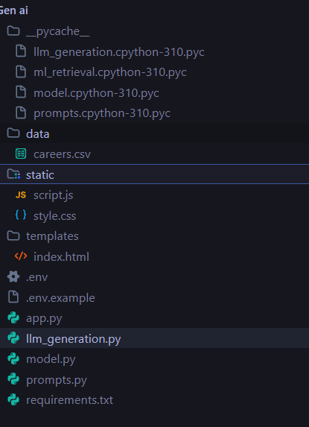

Code:
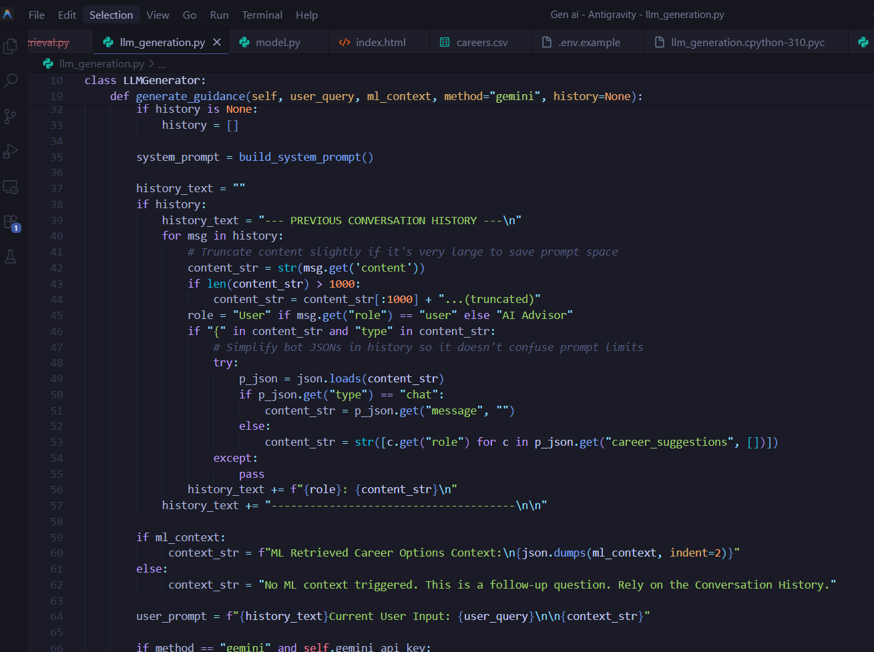
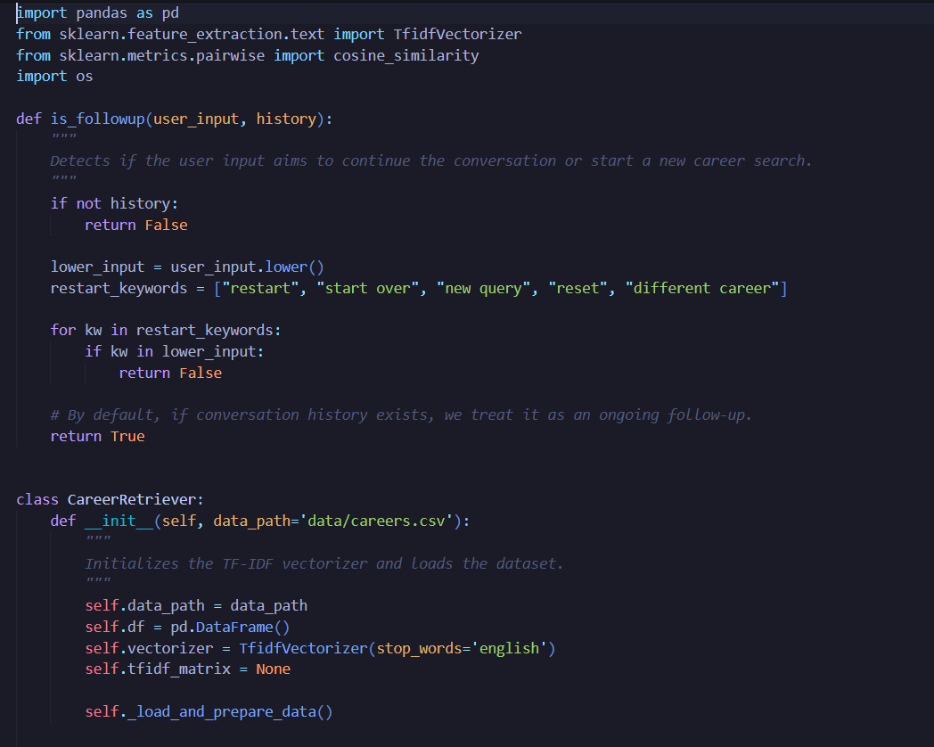

Data Set:
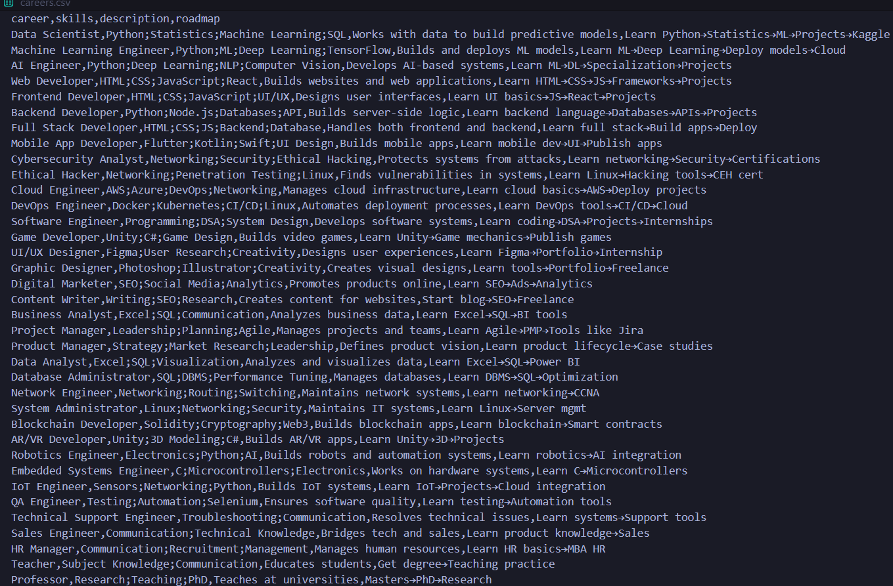

Terminal:
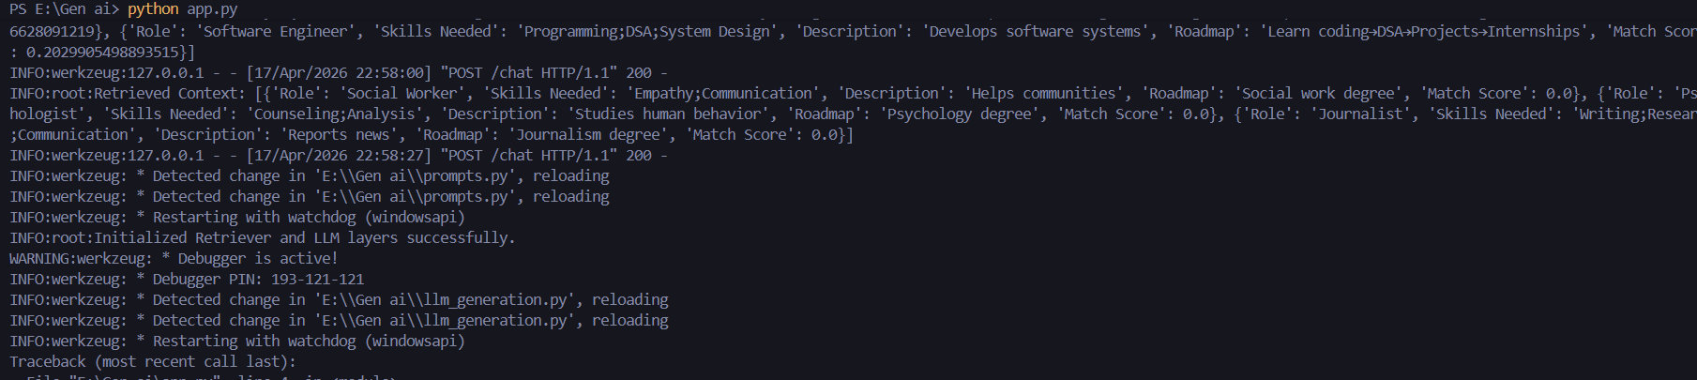

🟦 RESULTS AND OUTPUT
The chatbot successfully:
- Accepts user input
- Identifies relevant careers
- Generates structured responses
Example:
Input:
I like coding and AI
Output:
- Career Suggestions: Data Scientist, AI Engineer
- Skills: Python, ML, Deep Learning
- Roadmap: Learn → Build projects → Practice

Sample I/P and O/P:
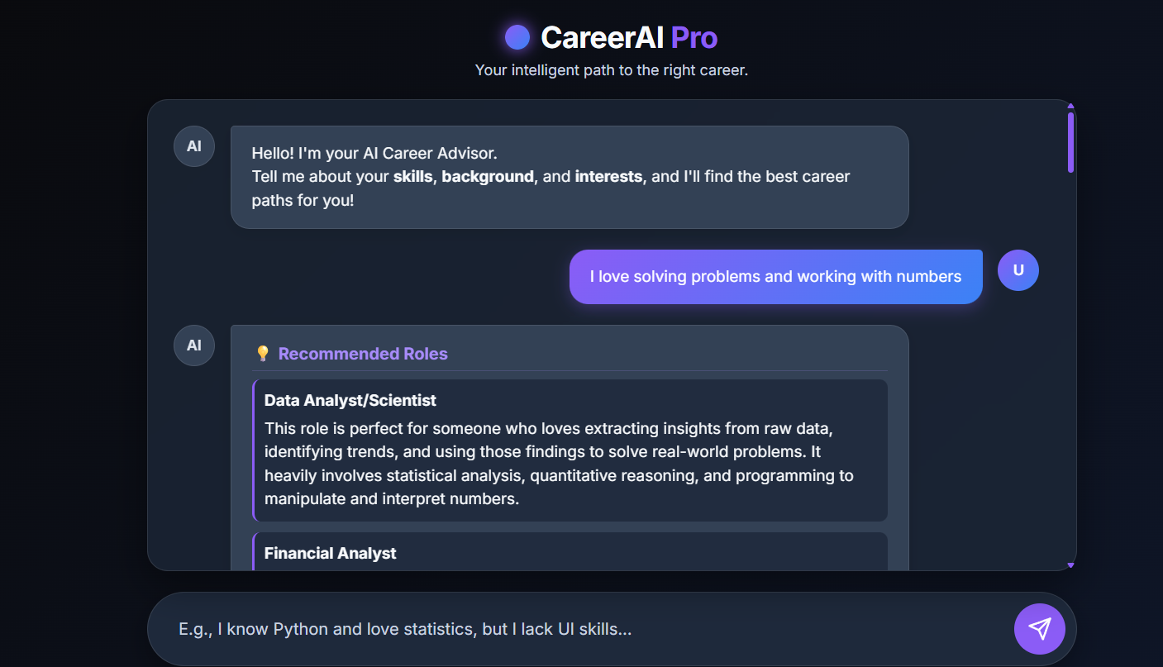
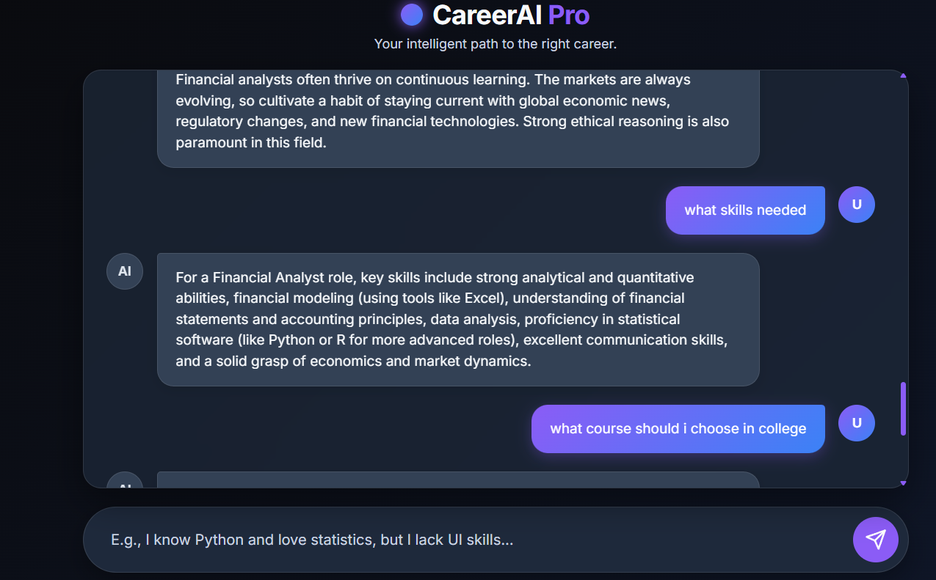

Video Sample:

https://drive.google.com/file/d/1mnMSGHtYsAFNKhMImdheoH1xYBaUp9NI/view?usp=sharing

https://drive.google.com/file/d/1iBthCYpWouwo6Rv8_UrEhBOX0CAUgtpe/view?usp=sharing

🟦 ADVANTAGES
- Personalized recommendations
- Interactive interface
- Combines ML and LLM
- Easy to use

🟦 LIMITATIONS
- Depends on dataset quality
- LLM may produce incorrect responses
- Limited domain coverage

🟦 FUTURE SCOPE
- Integration with real-time job data
- Mobile application development
- Voice-based chatbot
- Advanced recommendation algorithms

🟦 CONCLUSION
The Career Guidance Chatbot successfully demonstrates how Machine Learning and Large Language Models can be combined to create an intelligent and interactive system. The chatbot provides personalized career recommendations, skill suggestions, and learning paths, helping users make informed decisions.
This project highlights the potential of AI in education and career counseling and can be further enhanced with advanced features and real-world data integration.

